# CS 310 Changelog Template

**All notable changes made from the tutorial exercises for CS 310 using the JukeBox application will be documented in this file. Each version will match to a separate tutorial. Remember to start at the end of this file and work your way up. The most recent change will be located at the top of this document.**

Version 4.0.0 <Enter Date Here 2020-12-06>

Note: JosephSilva_Playlist

Major Changes:

• Created JosephSilva_Playlist class in student playlist.

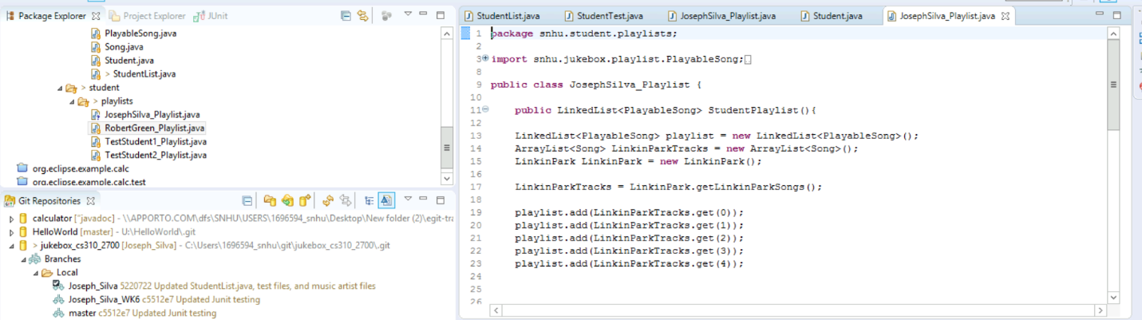

Minor Changes:

• Added code to JosephSilva_Playlist.java and added other created artist files songs to my playlist

• Created case statement for my profile.

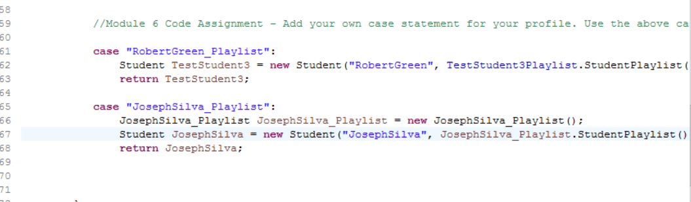

• Ran Junit Test to testGetJosephSilva_Playlist() and no failures/errors.

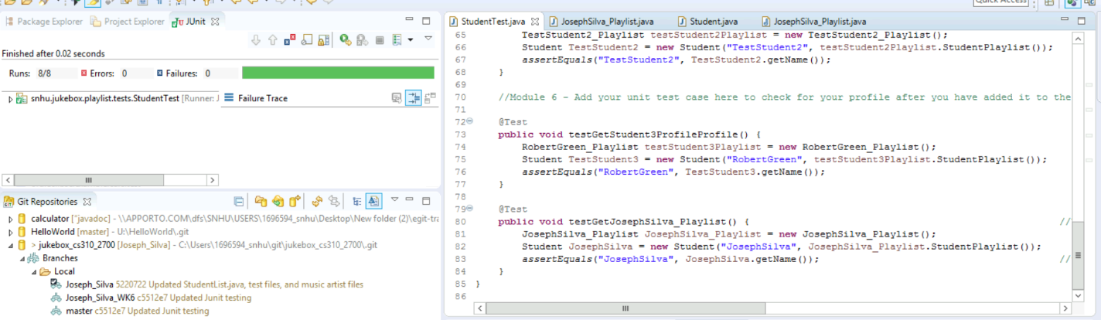

Bug Fixes:

• N/A

Version 3.0.0 <Enter Date Here 2020-11-28>

Note: Created Music Files

Major Changes:

• Created LinkinPark.java and BreakingBenjamin.java files in the music.artist package.

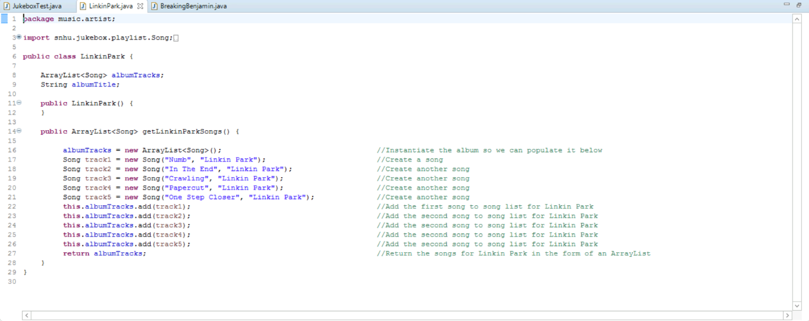

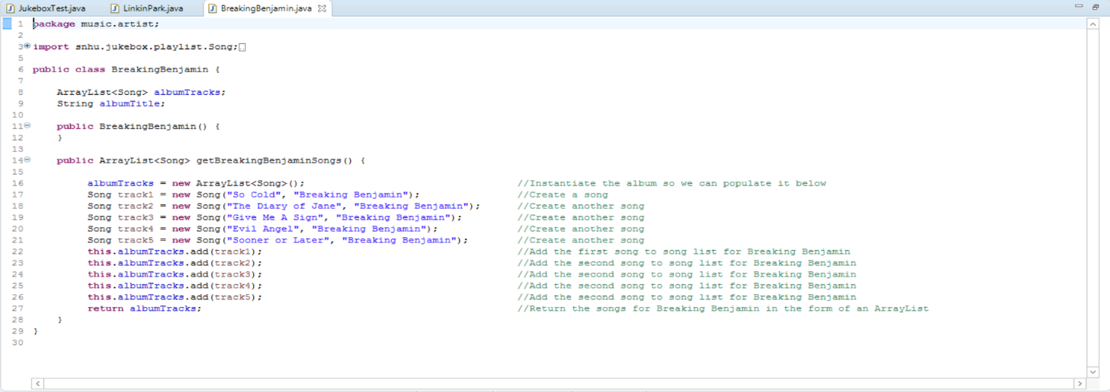

Minor Changes:

• Added code to JukeBox.test to test my LinkinPark.java and BreakingBenjamin.java files

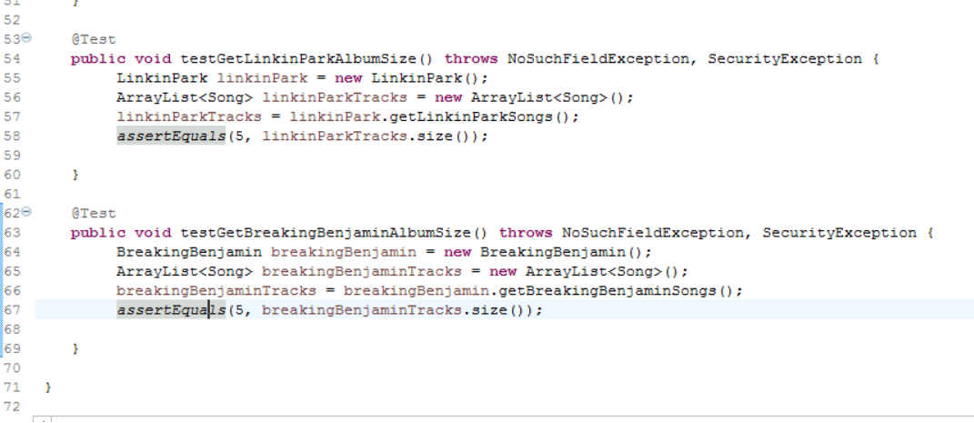

• Ran test on JukeBox.java using a Junit Test configuration to check for any errors or failures.

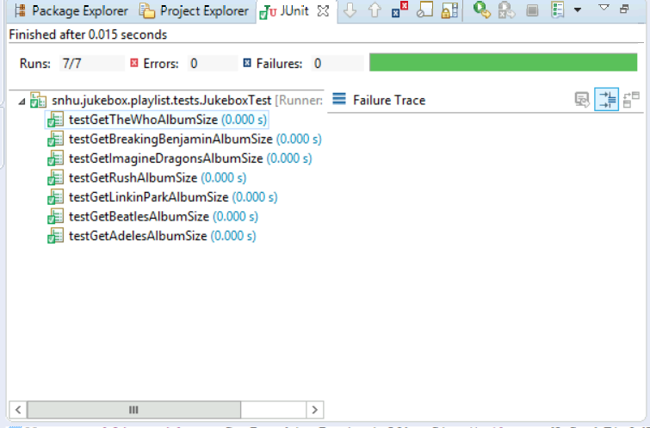

Bug Fixes:

• N/A

Version 2.0.0 <Enter Date Here 2020-11-28>

Note: Add my information to student list

Major Changes:

• Added my name to the studentlist.java file. 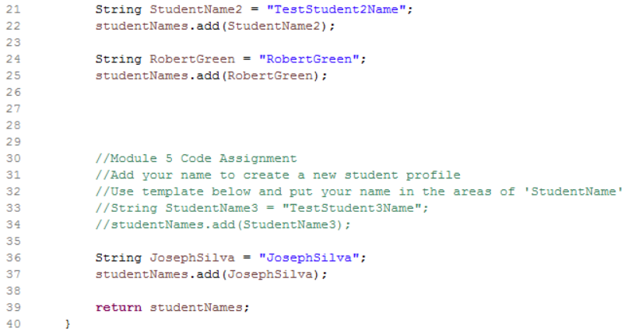

Minor Changes:

• Added code to StudentTest.java to test the code that added my name into the studentlist.java

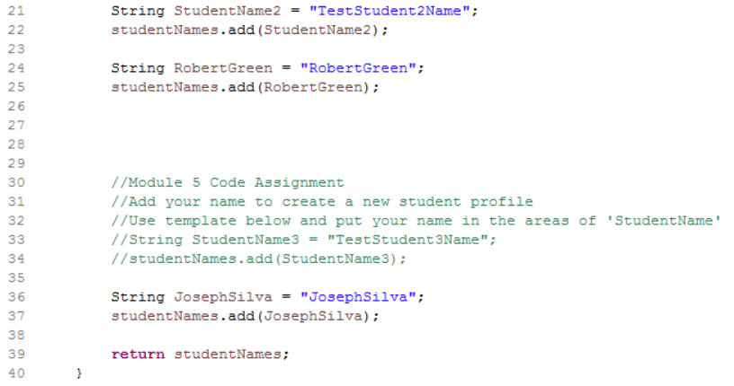

• Ran test on StudentTest.java using a Junit Test configuration to check for any errors or failures.

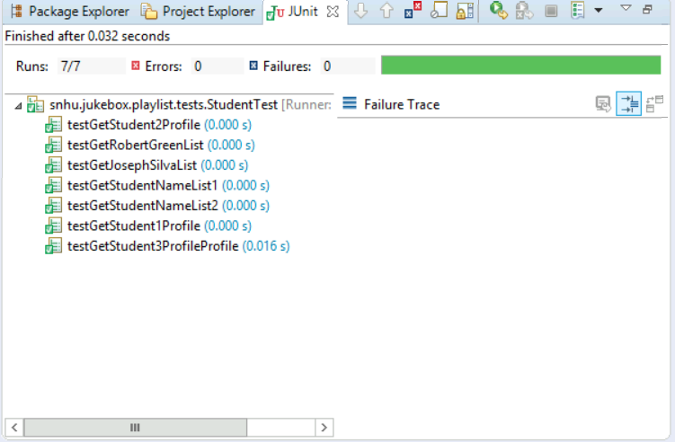

Bug Fixes:

• N/A

Version 1.0.0 <Enter Date Here 2020-11-28>

Note: Created a local repository by cloning the central Bitbucket repository

Major Changes:

• Local repository created by cloning jukebox central Bitbucket repository

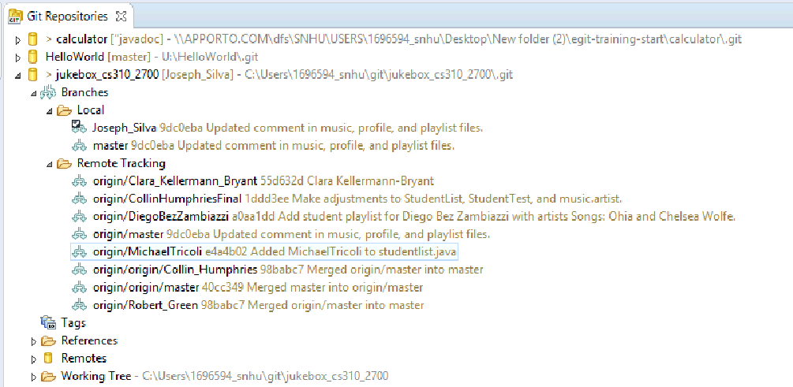

Minor Changes:

• Created a local branch with my name in order to work parallel with central repository.

Bug Fixes:

• N/A

**All notable changes made from the tutorial exercises for CS 310 using the Calculator application will be documented in this file. Each version will match to a separate tutorial. Remember to start at the end of this file and work your way up. The most recent change will be located at the top of this document.**

## Version 10.0.0 <Enter Date Here 2020-11-22>

**Note**: Remember that a changelog works in chronological order from newest to oldest. See section Version 1.0.0 for example data from the first tutorial. Add your own data to section Version 2.0.0 with details from your work in Tutorial Two and section Version 3.0.0. with your work from Tutorial Three.

Note: Tutorial Three – Stashing Changes in EGit

Major Changes:

* I added @since 1.0 to the BinaryOperation.java file. I was than able to stash the commit change of the file. I then was able to compare this updated BinaryOperation.java file with the original BinaryOperation.java file side by side.

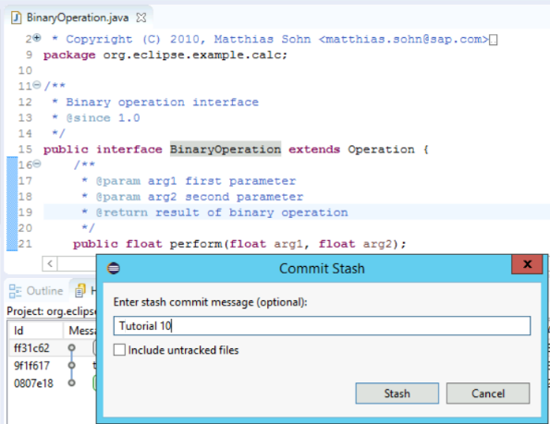

Minor Changes:

* I switched to create new branch and named it Javadoc. The branch had added code of @since 1.0 and then I applied the stash commit to the main line of code.

Bug Fixes:

* N/A

## Version 9.0.0 <Enter Date Here 2020-11-22>

**Note**: Remember that a changelog works in chronological order from newest to oldest. See section Version 1.0.0 for example data from the first tutorial. Add your own data to section Version 2.0.0 with details from your work in Tutorial Two and section Version 3.0.0. with your work from Tutorial Three.

Note: Tutorial Three – Inspecting the History

Major Changes:

* I was able to inspect the history of the calculator.java file. I had to use an extra step to get this information over the tutorial step. I right clicked in the editor area of eclipse and clicked on revision information. I then clicked on revision and it showed me who had made the changes for specific lines of code. I was able to see I made the changes to the specific lines of code by recognizing my school ID next to the lines of code.

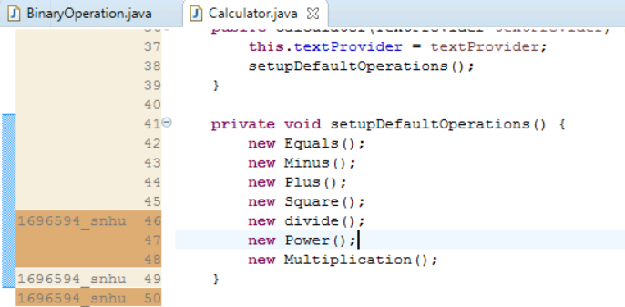

Minor Changes:

* I went into the History log for my commits and I right clicked on one of my commits. The log showed me the date of when this branch of code was committed, and it also brought up the created branch for this code to allow me to review after I clicked on revision information.

Bug Fixes:

* N/A

## Version 8.0.0 <Enter Date Here 2020-11-22>

**Note**: Remember that a changelog works in chronological order from newest to oldest. See section Version 1.0.0 for example data from the first tutorial. Add your own data to section Version 2.0.0 with details from your work in Tutorial Two and section Version 3.0.0. with your work from Tutorial Three.

Note: Tutorial Eight – Change a series of commits

Major Changes:

* Amended changes and committed new code which created a new branch

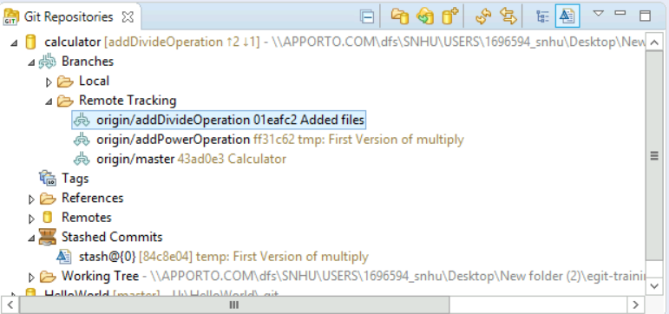

Minor Changes:

* Attempted to use Cherry Picker tool, but no changes were made.

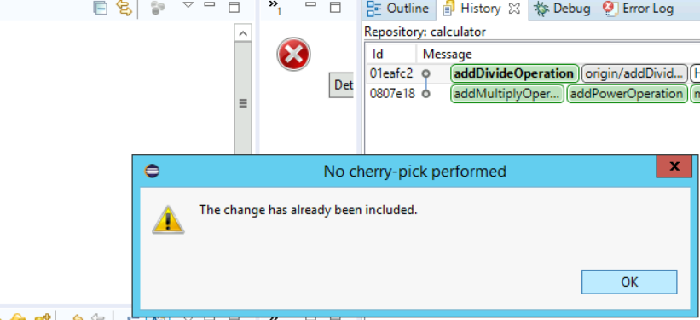

Bug Fixes:

* N/A

## Version 7.0.0 <Enter Date Here 2020-11-15>

Note: Tutorial Seven – Reset Branches to Previous State

Major Changes:

* Reset addDivideOperation branch because addMultiplicationOperation and addPoweroperation were not supposed to be with this branch.

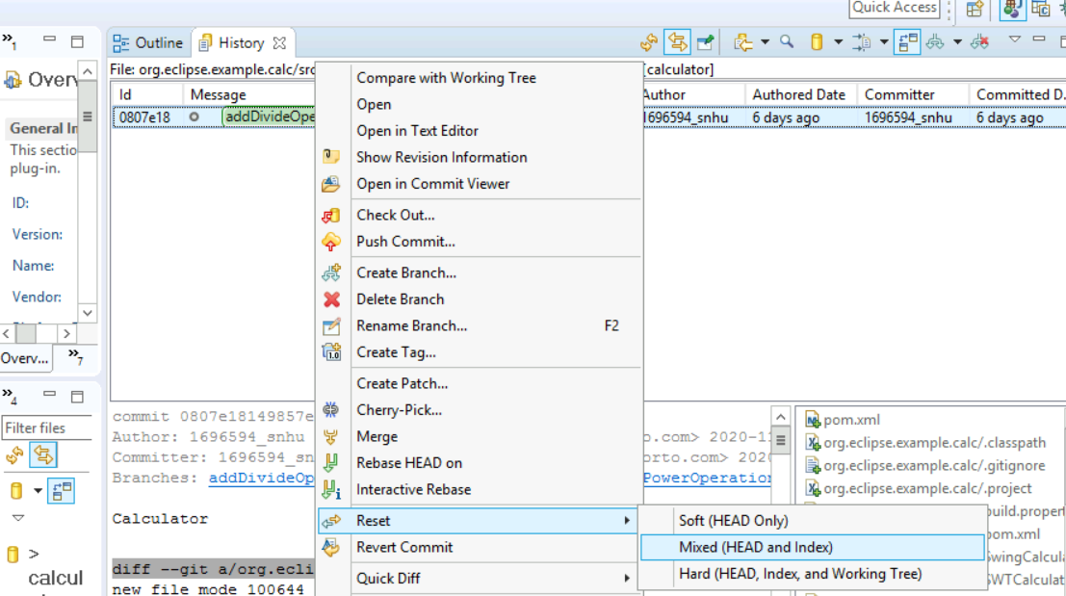

Minor Changes:

* Updated addDivideOperation branch without power and multiplication branch

Bug Fixes:

## Version 6.0.0 <Enter Date Here 2020-11-15>

Note: Tutorial Six – Merging, Rebasing, and Resolving Conflict

Major Changes:

* I already merged the addMultiplicationOperation and other branches to the main branch

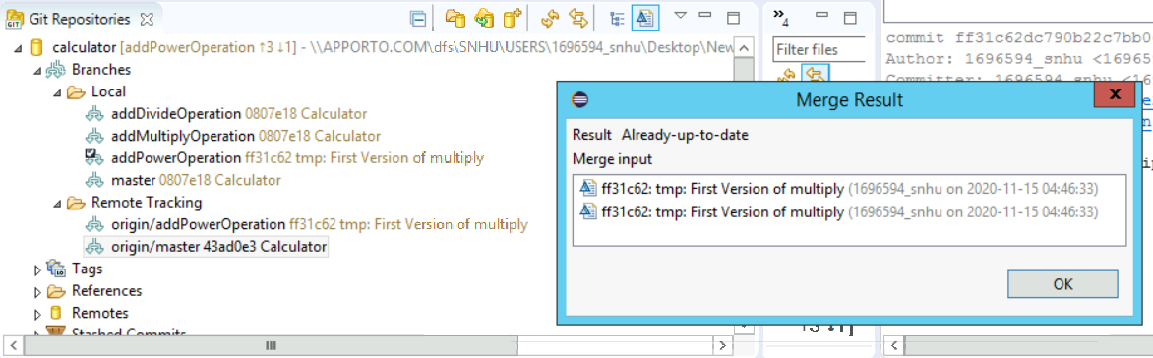

Minor Changes:

* Undid merge with reset
* Used merge tool instead of merging
* Was able to take care of conflict by rebase

Bug Fixes: N/A

## Version 5.0.0 <Enter Date Here 2020-11-15>

Note: Tutorial Five – Fetch the Latest State from Upstream

Major Changes: N/A

Minor Changes:

* Already up to date

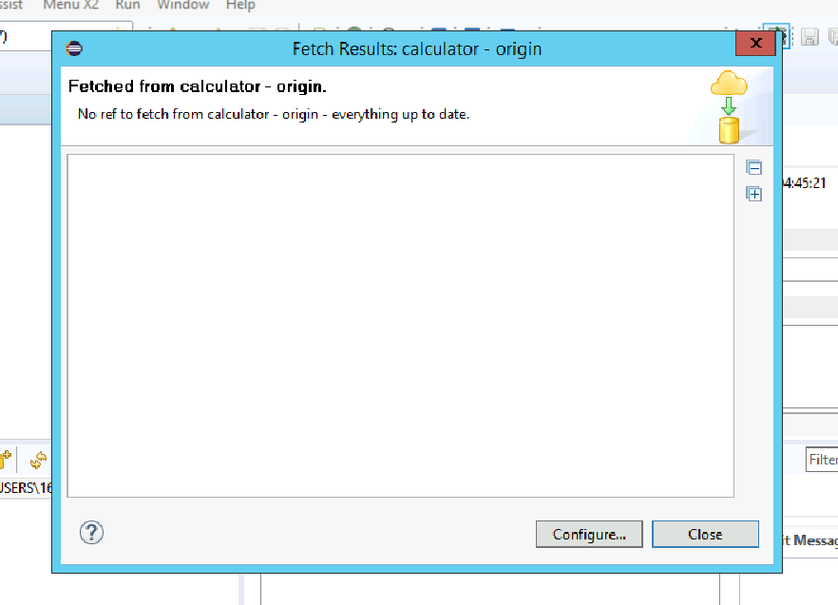

Bug Fixes: N/A

## Version 4.0.0 <Enter Date Here 2020-11-15>

Note: Tutorial Four – Work on Branches in Parallel

Major Changes:

* Created new branch addMultiplicationOperation

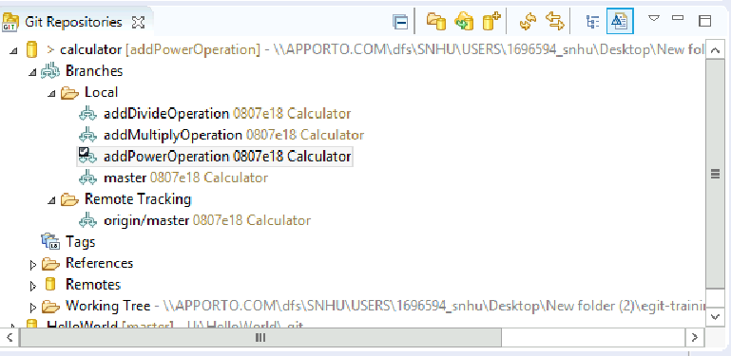

* Created new Multiplication.java class

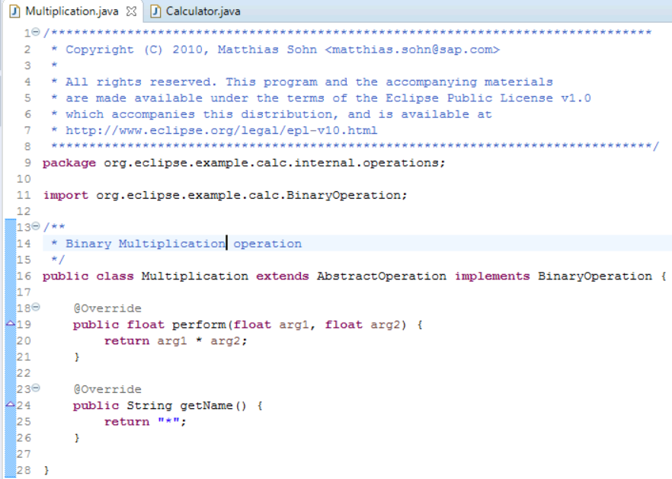

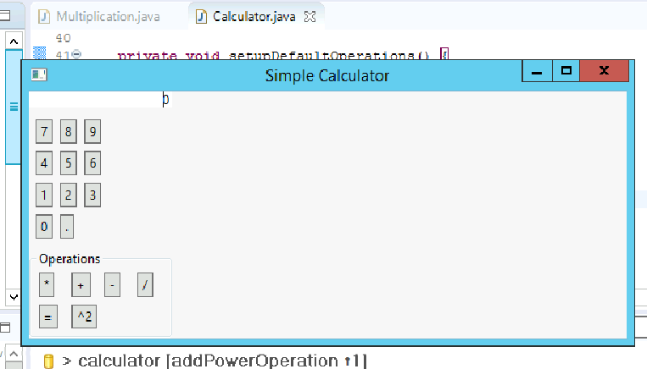

Minor Changes:

* Updated Calculator.java to implement to Multiplication.java

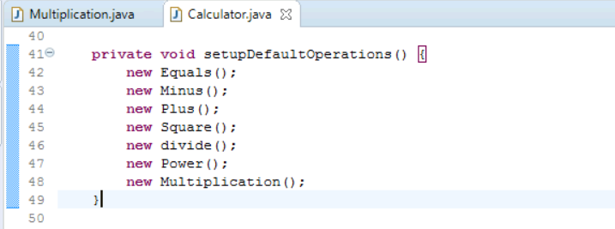

Bug Fixes:

* I am able to run Calculator.java file if I go around the main Calculator project folder and go to the org.eclipse.example.calc. folder also saved on project explorer.
* Still unable to manipulate main Calculator project folder due to it still being Maven.

## Version 3.0.0 <Enter Date Here 2020-11-08>

**Note**: Remember that a changelog works in chronological order from newest to oldest. See section Version 1.0.0 for example data from the first tutorial. Add your own data to section Version 2.0.0 with details from your work in Tutorial Two and section Version 3.0.0. with your work from Tutorial Three.

Note: Tutorial Three – Inspecting the History

Major Changes:

* <Enter each major change from Tutorial Three here as its own bullet point.>
  + <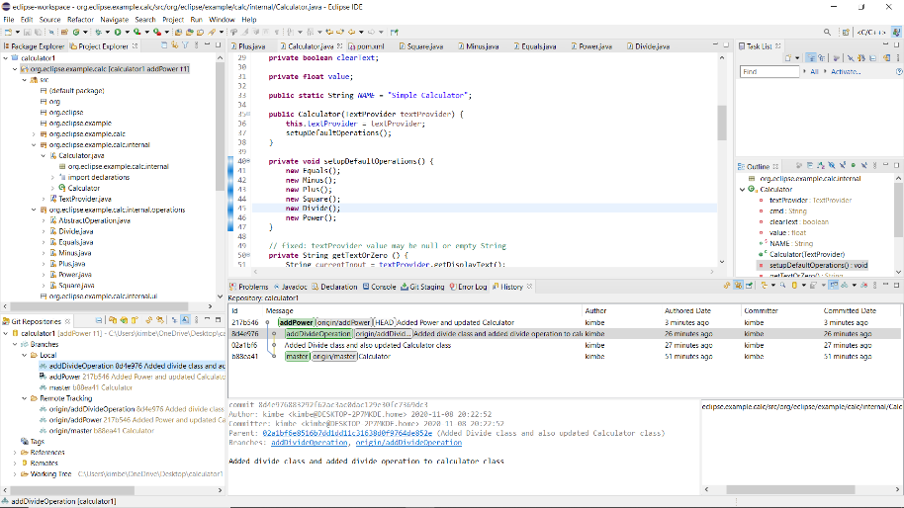>

Minor Changes:

* <Checked History of updated information and comment. History showed the creation of new branches. Used search bar to find any add in comments and/or branches. Compared the newly created braches>

Bug Fixes:

* <Enter each (if any) bug fix from Tutorial Three here.>

## Version 2.0.0 <Enter Date Here 2020-11-08>

Note: Tutorial Two – Develop Another Feature and Use Staging View

Major Changes:

* <Created new addedPowerOperation Branch.
* Added new Power.java class>
  + <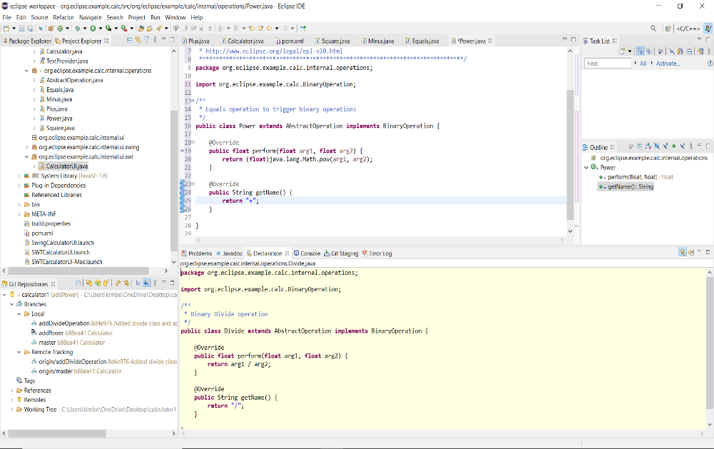
  + 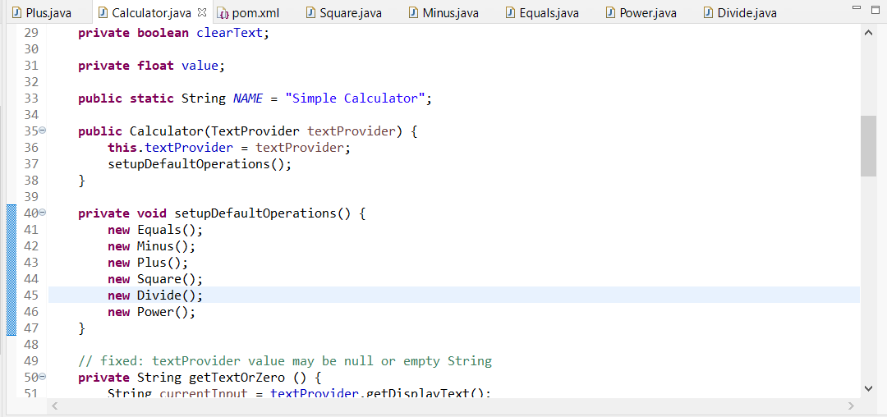>

Minor Changes:

* <Updated Calculator.java class with Power.>

Bug Fixes:

* <Enter each (if any) bug fix from Tutorial Two here.>

## Version 1.0.0 <Enter Date Here 2020-11-08>

Note: Tutorial One – Develop a Feature Bug Fix

Major Changes:

* <Created new addDivideOperation branch
* Added new Divide.java class>
  + < 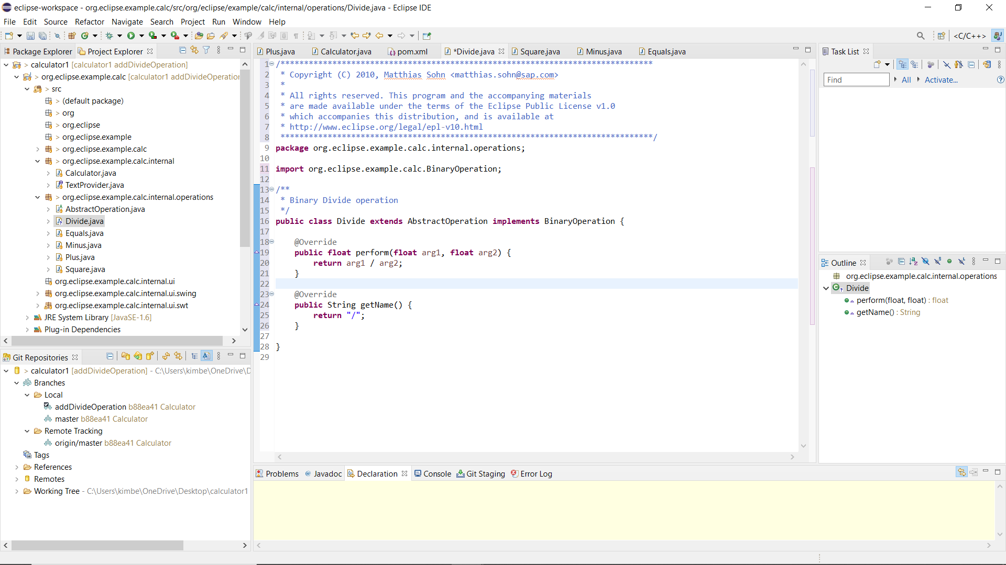
  + 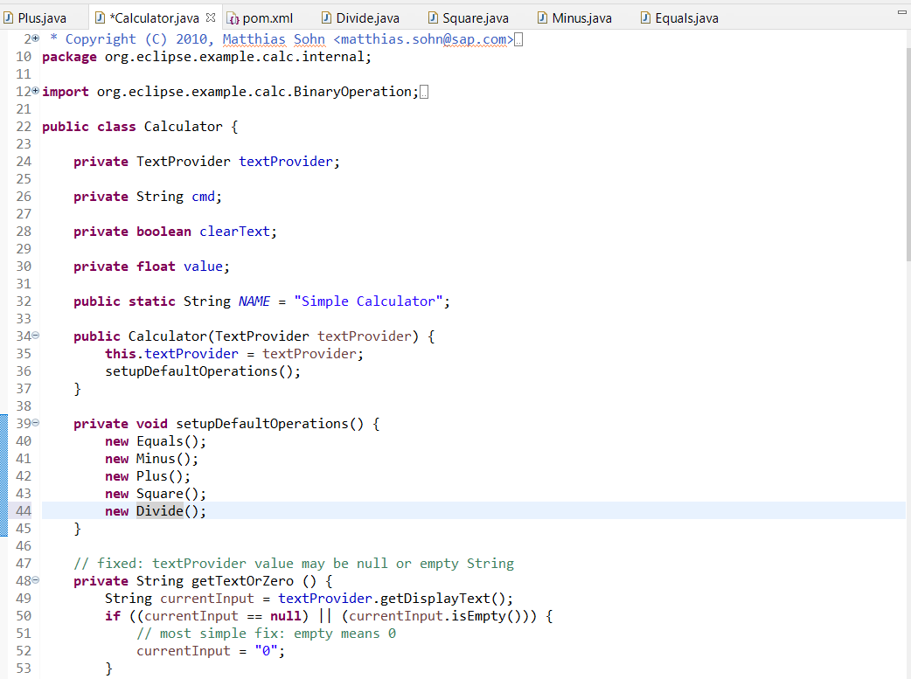>

Minor Changes:

* <updated calculator class with new Divide class
* Committed change to local respiratory>

Bug Fixes:

* <Got Rid of Maven upload, but still unable to run application.>